CENTENNIAL COLLEGE
COMP 397: WEB GAME PROGRAMMING
Assignment II Part One: Mobile Game Proposal
DUE DATE: July 23, 2025

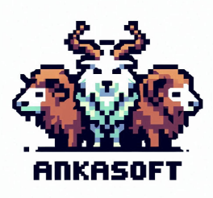

Polyguns
Version #1

Student: Naomi Mendoza – 301292515
Supervisor: Prof. Alireza Moghaddam

All work Copyright © 2025 by ղąցìղì from ANKASOFT Games.
All rights reserved.

2025/07/23

TABLE OF CONTENTS
I. GAME OVERVIEW 3
II. GAME CONCEPT 3
III. GAME PLAY MECHANICS 4
IV. STORY AND SETTING 5
V. User Interface (UI DESIGN) 6
VI. ART & AUDIO STYLE 8
VII. TECHNICAL DETAILS 8
VIII. DEVELOPMENT PLAN 9

I. GAME OVERVIEW

Working Title
Polyguns

Genre
Casual Arcade Shooter

Target Audience
- - General audiences
- - Fans of arcade shooters
- - Casual mobile gamers
- - Players who enjoy fast-paced, reflex-based challenges

Platform(s)
- Android (v9+)
- iOS (12+)

II. GAME CONCEPT

Polyguns embraces a retro-inspired minimalist 3D geometric shapes run smoothly on mobile devices. Players begin as simple triangles and evolve into complex polygons where the number of sides represent the level of power. This shape-versus-shape mechanic challenges players to constantly assess their evolving polygon against incoming threats with the thrill of having both top-view and pilot view game experience.

III. GAME PLAY MECHANICS

Polyguns allow players to steer a polygonal ship with auto fire and forward-moving camera. Enemies cascade from the top, each with toughness equal to its sides, driving players to choose optimal bullet shapes and dodge incoming fire.
Progressive waves introduce mini‐bosses and full bosses at set intervals, keeping the challenge fresh as players chase high scores and survival.

Player Controls and Interactions
- Virtual joystick enables movement up, down, left, and right within screen bounds
- Choice of camera view between top-view or pilot view
- Choice of polygonal bullets in ammo, deciding to match the player’s opponents
- Strategic positioning and precise dodges are essential to avoid enemy projectiles

Main Objectives and Challenges
- Survive endless waves of descending polygon enemies
- Match bullet side count to enemy toughness for maximum damage
- Navigate environmental obstacles in later levels (debris, gravity fields)
- Defeat mini‐bosses every 5 waves and major bosses every 10 waves

Game Progression / Level Structure
- Infinite wave‐based progression through three themed stages:
  - Level 1: Flat Grid Space – open arena with a faint grid, no obstacles
  - Level 2: Fragmented Orbit – with drifting debris that blocks movement and shots
  - Level 3: Void Core – black‐hole gravity curves bullets; hazards intensify combat

- Milestone foes: mini‐boss at waves 5, 15, 25… major boss at every 10th wave
- Game ends when all three lives are lost; “Game Over” screen shows final score and retry options

Scoring and Reward System
- Base score equals the enemy’s side count (e.g., square = 4 points)
- Boss victories grant large one‐time score boosts
- EXP meter tracks evolution separately from score—full bar upgrades polygon shape
- Occasional power‐up drops (EXP multiplier, health pack, shield) provide temporary buffs

IV. STORY AND SETTING

You take on the role of the final geometric defender left to safeguard an abstract realm of ever-shifting space vistas. Endless waves of enemy polygons—starting as simple circles and escalating to deadly dodecagons—descend from above, each shape more complex and resilient than the last. Your mission is to survive, evolve your polygonal form, and repel the relentless onslaught.

Game World and Setting
The battlefield unfolds across surreal, dynamic space backgrounds that pulse and morph with each wave. Level themes progress from a stark, grid-lined void to fields of drifting polygonal debris, then into the gravity-warped depths of a black-hole core. Each environment introduces new visual flourishes and tactical obstacles, reinforcing the minimalist, neon-infused aesthetic.

Main Characters
- Player Ship
  - Evolves from a Triangle to a Decagon as you earn EXP
  - Shape determines maximum HP, bullet damage, and animation style
  - Displays a brief blinking cue when hit, but retains its form until evolution
- Enemy Ships
  - Appear as various polygons representing health tiers (Circle = 1 HP, Triangle = 3 HP, Square = 4 HP, etc.)
  - Descend in patterned waves to challenge the player’s shape-matching tactics
- Boss Ships
  - Multi-faceted polygons that shift form mid-battle
  - Require specialized strategies and higher-sided bullets to defeat

V. User Interface (UI DESIGN)

The UI for Polyguns is clean and minimalist, mirroring the game’s geometric aesthetic. Menus use simple and clear typography. In-game HUD elements are: score, lives, HP, Player Position and EXP, so players can focus on fast-paced action without clutter.

MAIN MENU Screen:

Includes buttons for:

Start – Begins a new game session and transitions to gameplay.

Load Game – Loads last saved Game

Upgrades – Opens the upgrade menu where players can view their progression and unlock new shapes or bullet enhancements.

Options – Opens the options menu for volume and gameplay settings.

Credits – Displays a screen with acknowledgments to the developers and contributors of the game.

PLAYER STATS Screen:
On-screen display for in-game Player view; both in Pilot and Top Camera Views:
LIFE Points represented as spinning coins.

Positional Longitude, Latitude, of Player’s ship.
EXP/Point accumulated and progress toward the next evolution.

Indicates the required EXP for the next upgrade.

Displays bullet upgrade options unlocked through gameplay progression or pickups.

In-Game PAUSE Screen (ESC button):
The pause screen ensures that game progress is preserved unless the player chooses to restart or quit.
Freezes the game and overlays a pause window with the following options:

Resume – Returns to the game from where it was paused.

Restart – Restarts the current round.

Quit – Returns the player to the MAIN MENU screen.

GAME OVER Screen:
Shown when the player loses all lives or completes the final level. Displays the player's final score and shape level reached.

Includes Retry button to restart the game from the beginning.

Includes Return to Menu button to go back to the MAIN MENU.

Game Sketch:
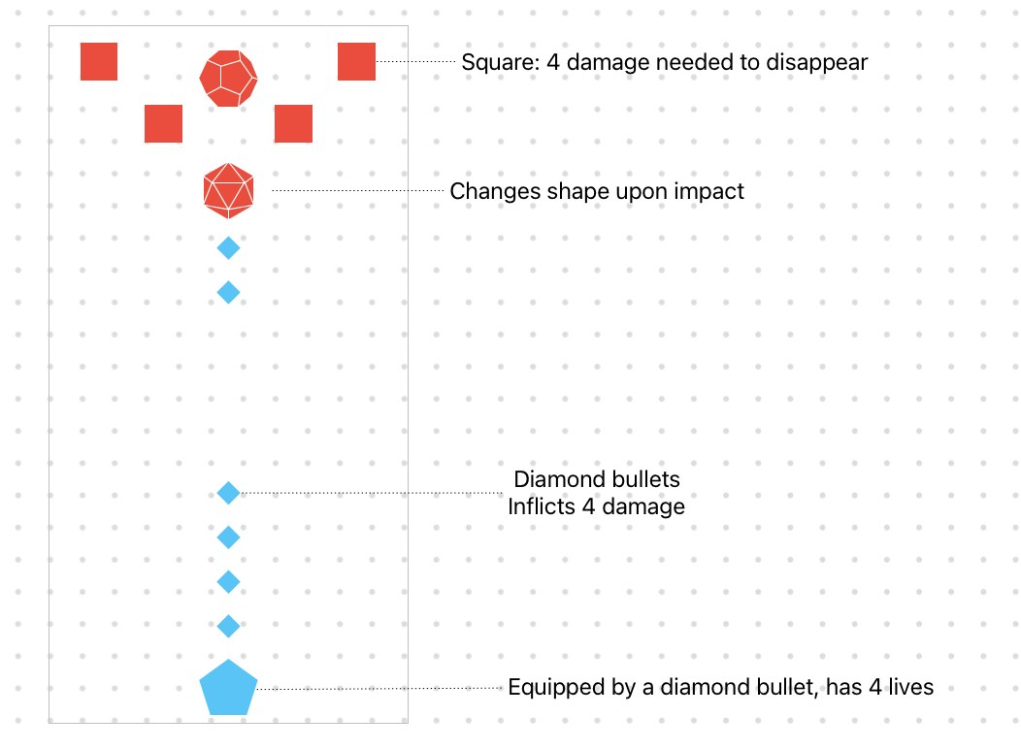

VI. ART & AUDIO STYLE

Visual Style
- Minimalist vector polygons with neon outline glows
- Dynamic particle effects for shooting, hits, and evolution
- Pastel-to-neon color gradients that evolve with player progression
- Smooth animations: idle blinking on hit, shape morph transitions

Planned Use of Audio
- Background Music: looping synthwave tracks sourced from the Unity Asset Store
- Sound Effects: neon “zap” lasers, polygonal burst impacts, and evolution chimes
- Audio Cues: distinct sounds for power-up drops, boss spawns, and wave completions

VII. TECHNICAL DETAILS

Game Engine and Framework
- Unity 3D (2024 LTS) with C# scripting
- Export as an Android library and integrate into an Android Studio project for mobile compatibility

Key Technical Features and Requirements
- Target Platforms: Android 9+ (API Level 28 or higher)
- Screen Orientation: Portrait (9:16 aspect ratio)
- Input System: On-screen virtual joystick for movement and a fire button; full multi-touch support
- Rendering: Lightweight shaders, optimized particle systems for neon VFX, and vector-style materials
- Performance:
  - 60 FPS target on mid-range devices
  - Object pooling for bullets, enemies, and particles to minimize GC spikes
- Asset Management: Addressable Assets System for dynamic loading of sprites, audio, and VFX
- Build Pipeline:
  - Unity Cloud Build or CI/CD integration for automated Android and iOS artifacts
  - Android packaging and signing handled by Gradle scripts in Android Studio
  - iOS packaging via Xcode project generated by Unity
- Data Persistence: PlayerPrefs for simple settings and JSON files for extended stats or leaderboards
- Optional Integrations: Google Play Games Services (achievements, leaderboards), Apple Game Center, and in-app purchase plugins for monetization

VIII. DEVELOPMENT PLAN

From July 23 to August 13, I have a three-week sprint structure, reserving the final week for playtesting and submission:

Phase | Dates | Tasks
Pre-Production & Setup | July 23–29 | - Define scope & feature list  - Set up Unity project  - Set up Android Studio pipeline  - Implement player movement, shooting, enemy spawn
Prototype Completion | July 30–Aug 5 | - Level Build  - Integrate HUD, menus, and UI flows  - Import Unity Asset Store audio
Playtest & Bug Fixes | Aug 6–12 | - Gather feedback on balance & controls  - Fix critical bugs and performance issues  - Finalize mobile builds
Submission | Aug 13 | - Freeze code/assets  - Perform final smoke tests on Android/iOS  - Package proposal  - submit mobile game deliverables

